Tripeersx.ifleetz.my

Product variants:

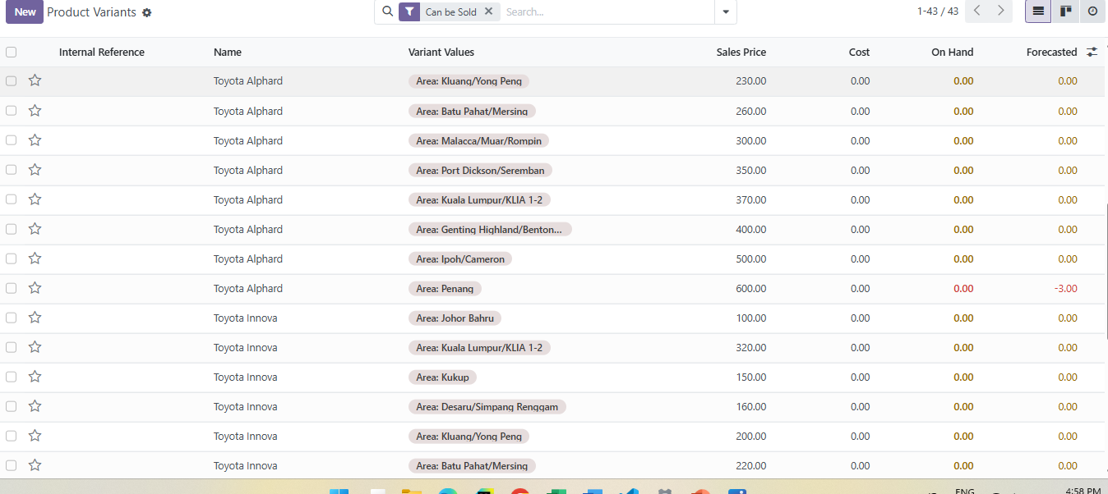

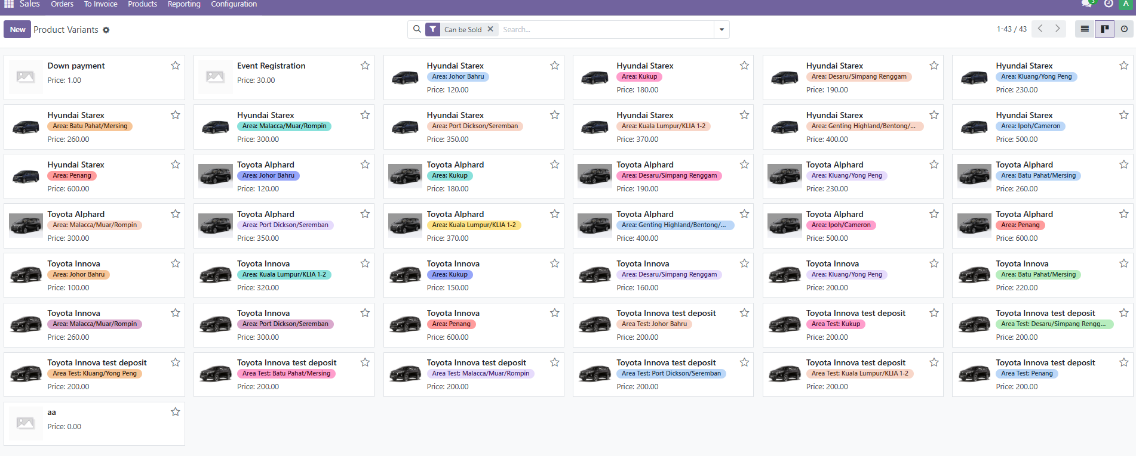

From the given information here, please provide business modules that how this thing works, especially I want to know:

1. That information involved, may I confirm that under those details are based on choosing the vehicles(name) and location area (variant values) occurred, what are those sales price, cost, on hand and forecasted (estimation)?

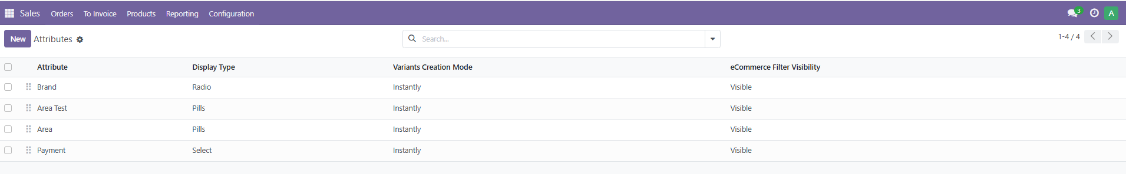

1. Under the picture above shows the product attributes from configuration:
   1. Is the brand related to the vehicles? Currently the brand is empty.
   2. Is the area test is used for testing purposes and area is for currently production mode, which is public to users to use? OR anything specific condition made for particular purpose?

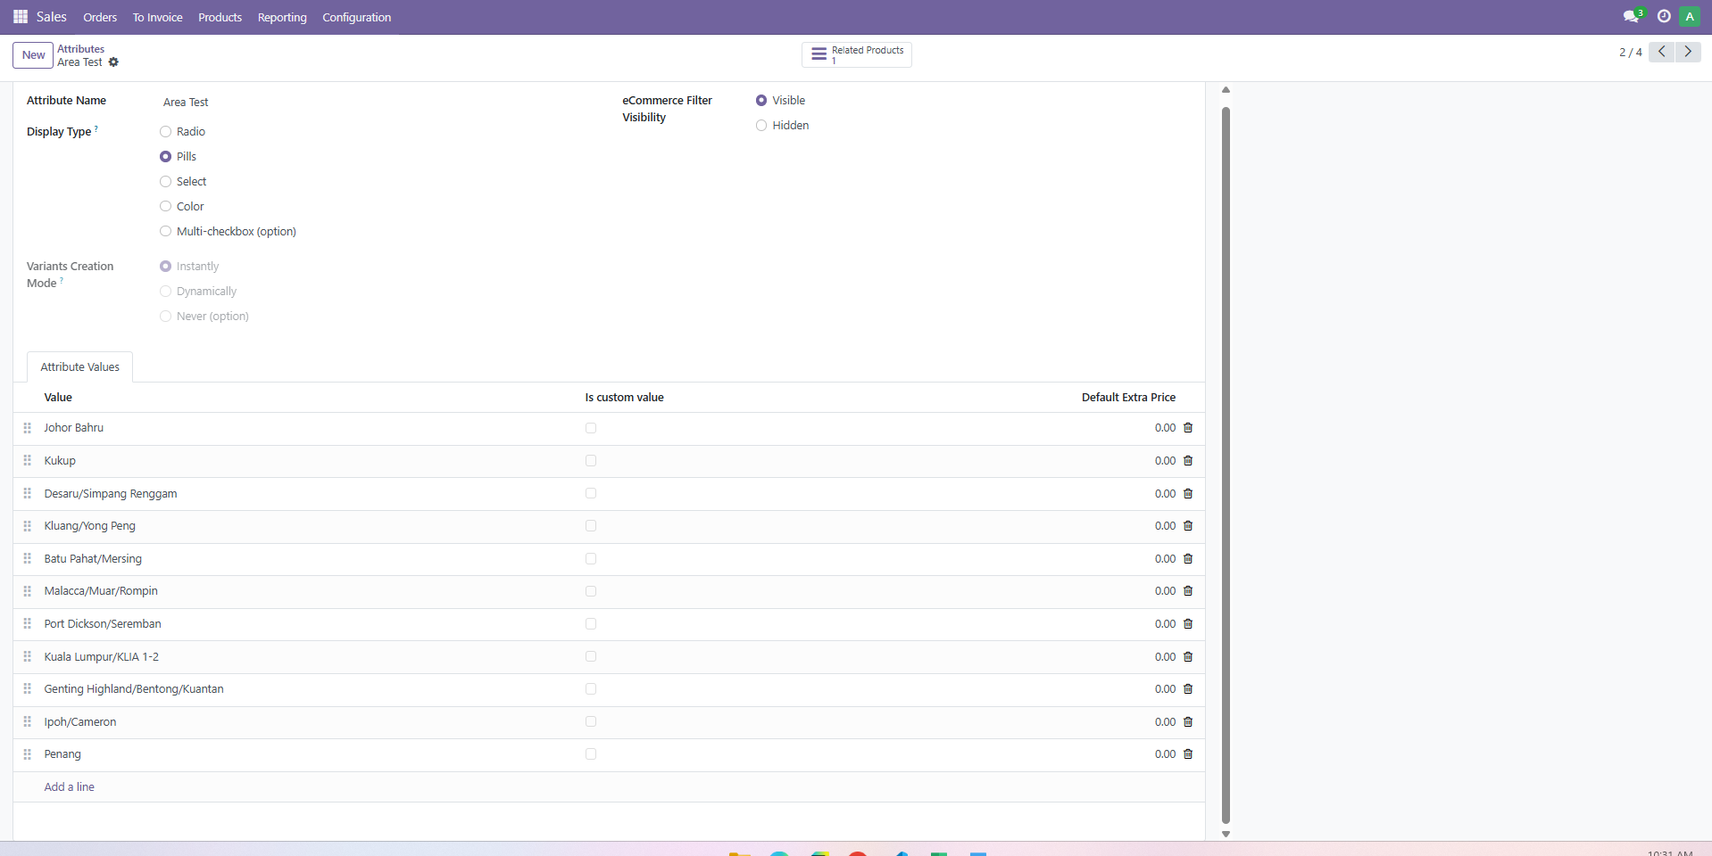

* 1. For the attribute values especially, the picture above shows the places with the extra prices. What purpose for this extra price used for? In addition, if required, what additional price is for every location?

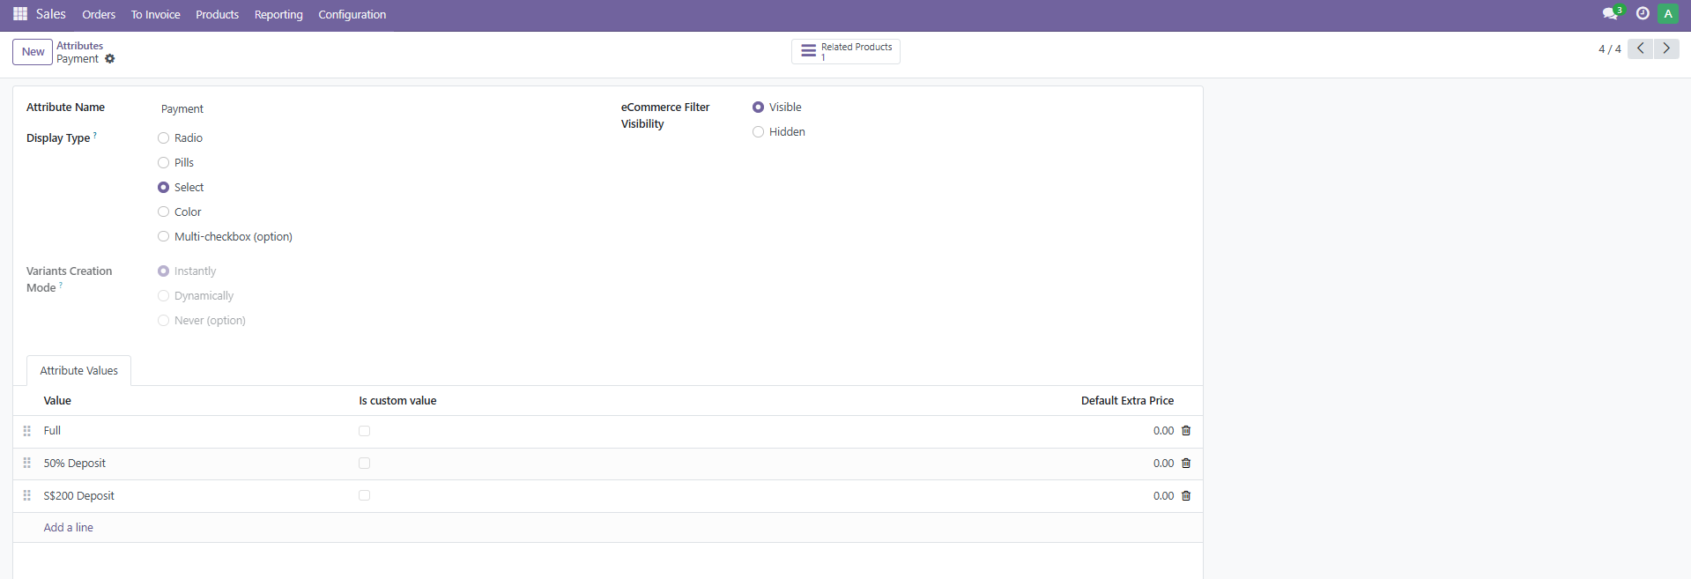

* 1. Payment, currently I found the full, 50% deposit and 200 deposit. This section, is it under the payment after booking as this part I’m lacking some information to know before tackling this?